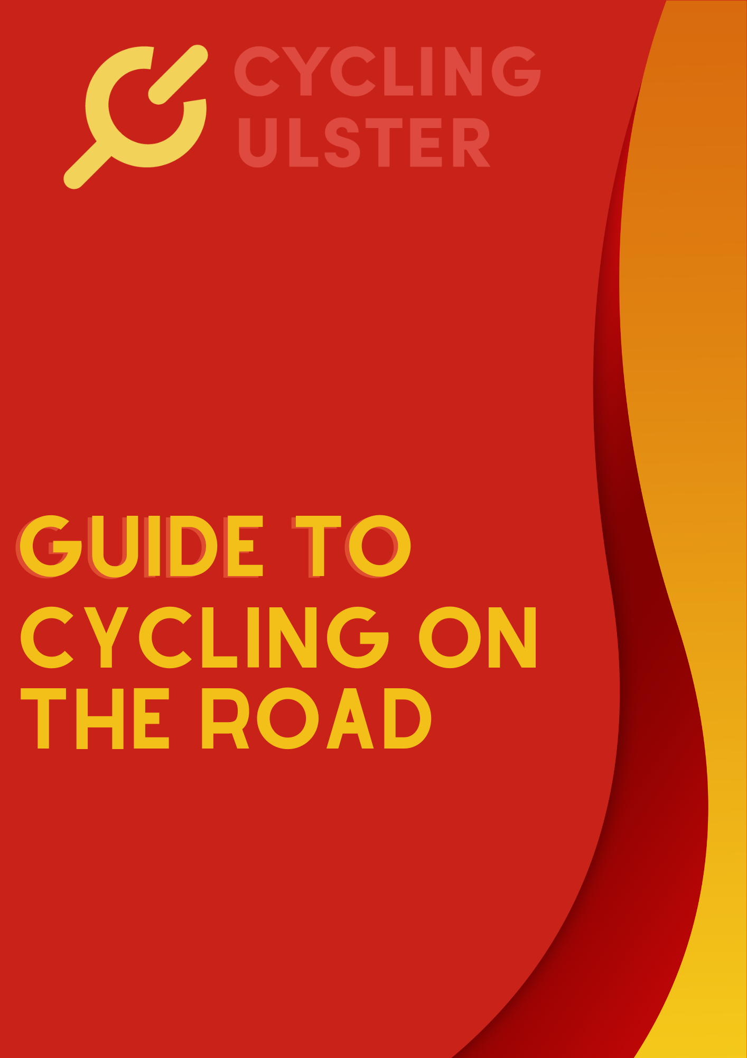
Guide for new cyclists

Pre-ride

Preparation and checks
Cycling Ulster encourage all cyclists, new and more experienced, to set time aside to prepare before venturing out on the road.

Bike check
All cyclists should complete an “M” check before each cycle. See Bike Check and Know your Bike for more information.

Tyres
Ensure tyres are fully inflated. This is one of the simplest things you can do that can have the greatest effect, and is often overlooked. Properly inflated tyres make pedalling easier, reduce the effort needed to maintain your speed, protects rims from damage, prolongs tyre durability and reduces the likelihood of experiencing a flat. For beginner cyclists it may not be clear what pressure you should pump your tyres up to. However, most tyres have a recommended pressure range (PSI) printed on the tyre side wall. Tyre treads need to be checked regularly for excessive wear or other damage, such as embedded glass or holes.

Brakes
You can check the breaks by spinning the wheels to ensure there is no rubbing. While the wheel is spinning apply the breaks to ensure the wheel stops smoothly evenly. Always check break pads for excessive wear and replace if necessary. Check cables and housing to make sure there is no fraying or splitting. Check the wheel quick release levers to ensure they are secure. Check for any loose parts or other mechanical problems. It’s a good idea to do a slow-speed ride and inspect bike, brakes, and shifting before departing.

Equipment

There is a wide range of equipment and accessories available for cyclists. However, there are a few essentials you should carry with you when out on a ride.

Tubes
Spare tubes are essential should you have a puncture whilst out on a ride. (Normal tube sizes are 700x25 or 700x28). A good pump or gas canisters are essential for pumping up a newly installed tube or slightly flat tyre when out. Gas canisters can easily fit into a saddle bag or a mini pump can be carried on your bike frame.

Saddle bag
Saddle bags are useful to carry a few important items and fit snugly under your saddle. Items to include in your saddle bag - tyre levers to help take off/put on a tyre. A multi tool may be needed for quick bike adjustments such as tightening loose bolts, adjusting saddle height or adjusting your cleats.

Lights
Front and rear lights. Lights are required by law if you are cycling at night. Before leaving on your ride make sure lights are fully charged and securely fixed on to your bike. Lights do two jobs; they make you more visible to other road users and help illuminate the road in front of you. Although lights are not legally required during the day, we encourage all cyclists to use them to help make themselves more visible to other road users.

Mud guard
A rear mudguard during winter months. Mud guards are essential in wet/mucky conditions as they help keep the spray from the road down. Keeping you dry and clean. Mud guards also protect some bike components and help prolong their lifespan.

Other accessories –
Map, routes or GPS devices are not essential but can make cycling easier. Bike computers are good for plotting and following a route, measuring your speed and distance as well as many other functions.
A mobile phone is handy if you get a mechanical you cannot fix, get lost or need help after an incident. ID or medical card are good items to have with you in case you have an accident.

Supplies

Fluids
Before leaving on your ride it’s important to make sure you have adequate fluids with you. Bottle frames are the easiest way to carry water bottles on your bike. It also means you can continue cycling while you reach and take a drink. Hydration packs are also available as a means of staying hydrated. Add fruit juice to improve the taste or use an energy drink instead. Having adequate fluids is extremely important if cycling on a warm day or taking part in a longer cycle.

Food
Carrying food or snacks is a good idea when going out for a cycle. The body can only store a certain amount of energy so it’s always good to have a few items of food to top up your energy reserves. Food isn’t as important on short rides but is the key to riding long distances.
It’s also a good idea to bring some cash with you in case of an emergency or to enjoy a rest at a coffee shop.

Cash for coffee stops or emergencies
Sunscreen/lip balm with sun protection

Clothing
Clothing
Cycling Ulster encourage all cyclists to ‘be safe be seen’ by wearing hi-vis/bright clothing at all times, especially during poor weather and lighting conditions. A waterproof cycling jacket is a good item to carry. In order to keep the rain out the jacket needs to fit while in the riding position. It needs to be longer at the back and arms so it doesn’t ride up and expose your back and arms.

Helmet
Ensure the straps are tight (can only get two fingers under straps) and the helmet is securely in place. For a helmet to be effective it must be properly fitted. As a guide the front of the helmet should sit just above your eyebrows. Helmets have a shelf life and need to be replaced every 3-5 years. Helmets should be replaced after a crash. Even if the protective padding seems to be intact you can’t be sure it can absorb and offer the same level of protection in a second impact.

Gloves
Padded to reduce pressure and road shock that can cause numbness or tingling fingers.

Shoes
Shoes can be trainers or specialist cycling shoes. Many cyclists start out using trainers until they get more confident and used to their bike. After a period of time most cyclists change to cycling shoes with cleats that fit into clipless pedals allowing them to lock into place. A simple twist to the foot releases the shoe from the pedal. Clipless pedals allow cyclists to pull up as well as push down on the pedals and create a much more efficient pedal stroke and faster speeds. Remember to check that cleats are not worn beyond the recommended limits. Worn cleats can cause the shoes to release from the pedal without warning.

Shorts/tights
Shorts/tights have a special padded area in the seat designed specifically for cycling which is necessary for comfort. Both are worn without underwear to avoid chaffing and help prevent saddle sores. They can also help improve your aerodynamics by providing a close fit to your body. Like any piece of equipment they will need replaced after a certain time.

Eyewear
Sunglasses or other eye protection are important for protecting your eyes against wind, insects, stones, dirt etc. Make sure sunglasses are the correct fit and don’t slip off your nose. You can get sunglasses with interchangeable lenses to adapt to different light conditions. Choose glasses with as much coverage as possible.

Bespoke gear to protect against the elements. This may include hi-vis rain jacket, arm/leg warmers, thermal jackets/jerseys, overshoes etc

Fuel and fluids

Fuel
There are plenty of specially formulated sports foods/snacks on the market. However, many items already in your cupboard are more than suitable to eat on a ride. The body can only store a certain amount of energy, so it is always good to have a few items of food to top up your energy reserves after 60-90 minutes of cycling.
Eat a healthy breakfast 30 to 60 mins before the start of your cycle. Porridge and a slice of toast/oat or wholegrain cereals are a good option. Light cereals such as cornflakes do not provide the slow- release energy you will need for a cycle lasting a few hours. Carrying additional food ensures you will fuel your ride, for example, bananas, cereal/energy bars, sandwich, handful of jelly sweets. This will help you avails ‘bonking’ on a ride, where your body runs out of fuel and you can’t continue riding.

Fluids
Drink plenty of water before your cycle to ensure you are well hydrated and try to drink and eat
as often as possible whilst out cycling (every 30 minutes). If you are nervous eating or drinking while on the move pull over and stop somewhere safe. If you run out of water you can nearly always find somewhere to refill along the way.

Solo Cycling

Communicating with other road users
A cyclist should know the rules of the road and understand signs and road markings. Please refer to the guide to cycling on the road for more information. Try to ride predictably and decisively as possible. Be clear and communicate your intentions to other road users. Looking ahead and all around you is an important aspect of cycling safely. It will help you to negotiate roads safely.

Safe road positioning

It is important to make sure you can be seen by other road users. Road positioning can make a big difference. The primary riding position is in the centre of the traffic lane, where you are most visible to following drivers. It is safer to take this position when negotiating road junctions, road furniture, uneven road surfaces and unsafe overtaking on narrow roads.

The secondary cycling position is to the left of the moving traffic and is used the most. On a wide road this is approximately 1 metre from the kerb and enables room to manoeuvre away from debris and drain covers. You can move back into the primary position whenever it is unsafe for vehicles to overtake you or when you need to emphasise your position to traffic ahead.
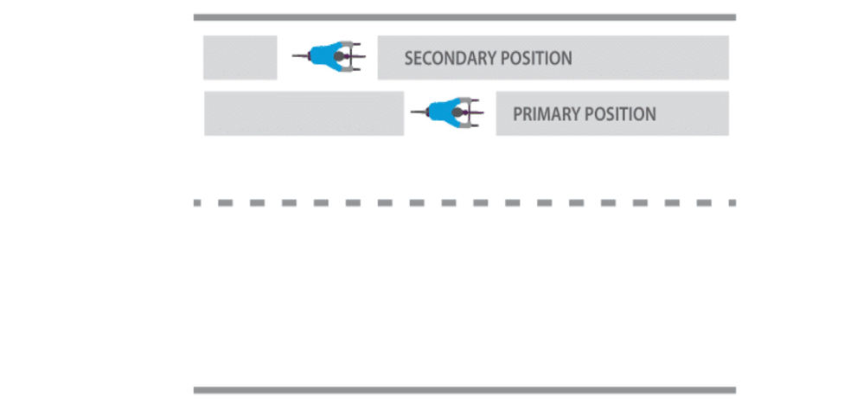

Signalling and cycling manoeuvres

Signalling
Using a systematic routine that includes frequent observations, correct road positioning and clear signalling is best when cycling through junctions. Anticipating what is ahead of you is important as it will give you more time to move safely. Good road positioning makes you more visible and gives you more control over those around you.

Hand signalling
On a bike, arm signals draw attention to you and tell other road users what you're doing next. Signalling as early as possible gives other drivers and cyclists plenty of time to react to your signalling. It is important that you hold the signal for a number of seconds before making your turn or coming to a stop.
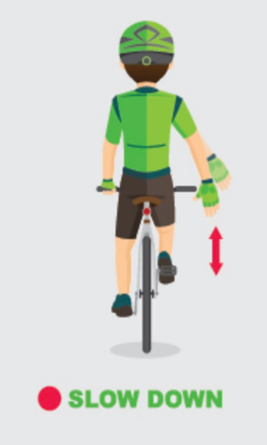

Communication with other road users isn't just about arm signals. Your position on the road and the direction you're looking also tell people where you're going next.

Cycling manoeuvres

Turning left
Position yourself in the centre of the lane making sure you are more visible to other road users. Slow down and signal clearly before reaching the junction. Turn left when it is safe to do so.

Turning right
Look over your right shoulder to make sure it is safe to move into a more central position making
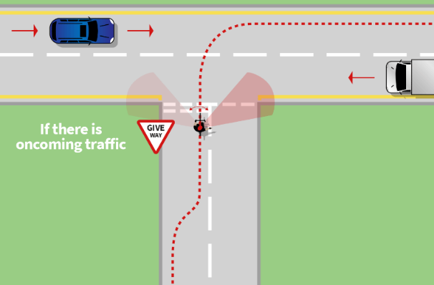
sure you are more visible to other road users. Slow down and signal clearly before reaching the junction. As soon as there is a safe space in the traffic continue the manoeuvre.
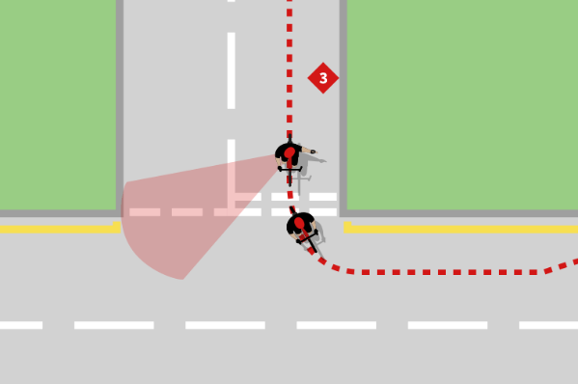

Turning right Turning left

Overtaking a parked car
When over taking a parked car make sure to look over your right shoulder to check for traffic, signal and move out into the primary position. Always leave enough room to pass safely if the car door opens unexpectedly.
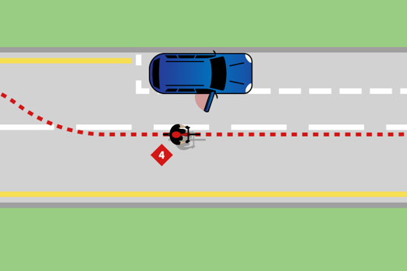

Puncture
Find a safe place to pull in and fix or repair the puncture. To fix a puncture you will need to remove the wheel before replacing the tube.

Gears and Cadence (pedalling speed)

Working your gears is one of the fundamental mechanical functions of your bike. Proper gearing will not only improve your speed, it will also make the ride more comfortable and increase your endurance on longer rides.

Low Gear = Easy = Good for Climbing: The “low” gear on your bike is the smallest chain ring at the front and the largest cog on the cassette. In this position, pedaling is at it’s easiest and you will be able to pedal uphill with the smallest amount of resistance.

High Gear = Hard = Good for Descending: The “highest” gear on your bike is the largest chain ring at the front and the smallest cog on the cassette. In this position, pedaling is at its hardest and you will be able to accelerate while traveling downhill.
Lower gears make the pedals easy to turn and it becomes easier to spin to a fast cadence. Pedalling faster in a low gear, rather than ‘harder’ in a high gear means you will last longer! During your cycle try to find a comfortable cadence you can maintain during the ride by moving up or down gears as road incline changes. Using your gears effectively will not only improve your speed it will also make the ride more comfortable and increase your endurance on longer rides.

Over time you should gradually try to increase your cadence. Most new riders think they are getting a better workout if every pedal stoke is a strain and the quads are burning. Although there's a place for low-cadence workouts, during a normal ride, aim for a smooth spin at between 80-100 rpm (pedal revolutions per minute) which is much more efficient and easier on the legs.

Cross Chaining
Cross chaining is a term that refers to one of the following gear combinations:
BIG/BIG: The largest cog in the cassette (easiest gear) and the largest chain ring (hardest gear)
SMALL/SMALL: The smallest cog in the cassette (hardest gear) and the smallest chain ring (easiest gear). In these positions, the chain is stretched at an angle that can cause damage to the drivetrain over time.

Handlebar grip
Always keep a good grip of your handlebars using you thumbs. Don’t rest your hands on top of the bars as this hand position decreases the amount of control you have over your bike should you hit a pothole, experience a strong crosswind or need to change direction suddenly.

Group Cycling

There are many benefits to riding in a group. It is considered safer, more sociable and more energy efficient. By riding in a group, you will benefit from riding with more experienced cyclists. There are, however, specific rules for which all riders must adhere to. These rules are accepted as good practice and make the experience more enjoyable for all riders.

Calls
Alerting the group to hazards such as potholes/parked cars/debris on the road is particularly important and cyclists within the group should communicate by calling out and signalling so that all riders are made aware of obstacles/conditions.
The cyclist at the front of the group should clearly and loudly announce hazards on the road ahead. These are announced early so the group is aware of the potential dangers and can smoothly and safely take evasive action. The cyclist at the front of the group calls the hazards and people behind repeat the call so the message gets passed through the group.

Examples of calls –
“Hole left” means there is a pothole on the left hand side.
“Stones on the right” means stones/gravel on the right hand side.
“Gravel in middle” means there is gravel in the middle of the groups path.
“Steady” may be called to slow the group down if a gap is appearing.
“Clear” is called to indicate that a junction is traffic free or that it is safe to proceed. Riders must check themselves and not rely solely on others.
“Rider up” is used to warn riders that the rider behind intends to pass. Riders should be prepared to move over or single out to accommodate the riders coming through.

Moving cars approaching the group
If a car is approaching from behind (or a car following the group is beginning to overtake the group) “car up” is called. The last person in the group should be aware of traffic following/approaching from behind. If a car is approaching the group from the front on a narrow road “car down” is called.

Punctures or mechanicals
The person who gets the puncture. Should call “puncture” or “mechanical” as soon as possible. The call should be repeated so that the message gets passed through the group. This alerts the riders that someone has an issue so the group can stop.
The call also alerts the riders cycling behind the person that has suffered the puncture that there is someone in the group who may need to stop immediately and that they need to be alert.
Signalling
As well as verbal calls group cyclists will also communicate by signalling any potential hazards to each other.

Moving out (1)
Hand signal: Bring hand behind the back (left or right
depending on which side the obstruction is on) and wave or point behind back indicating that there is an obstruction such as a parked car or pedestrian. Riders should move in the direction indicated to avoid the obstruction.

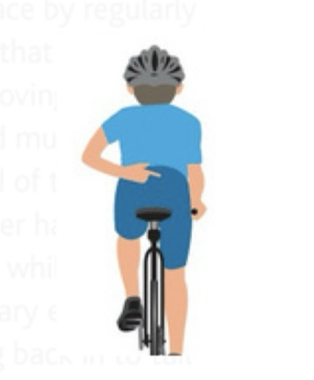

Pothole or hazard (2)
Hand signal: Extend arm (left or right depending on which side the hazard is on) pointing down at the road, to point out hazards such as potholes, manhole covers etc. In the case of a pothole, the rider
should shout ‘hole’ while pointing towards the hazard.
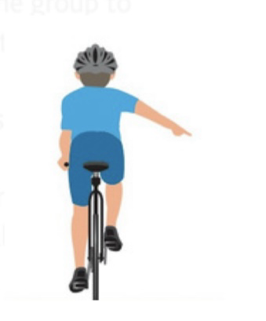

Glass/or loose gravel/uneven ground (3)
Hand signal: Extend arm (left or right depending on which side the hazard is on) with one hand open and palm facing the ground. Move hand left and right to indicate gravel or uneven ground.

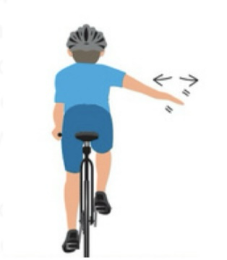

Safe riding position
The usual formation for a group is to ride in pairs in two parallel lines. Single file can be used depending on road conditions. Always stay in position and do not break suddenly or make any changes to your speed/position as this may compromise the safety of the group.
A cyclist should be scanning at least two to three riders ahead at all times – by doing this, riders will be aware of any problems further up the line.

Cycle two by two/2 Abreast
The cyclist in front can not see the position of the cyclist following behind. If your front wheel overlaps the rear wheel of the person in front, any movement left of right could result in wheels touching, a loss of balance and ultimately a crash.
‘Holding the line’ – cyclists in a group need to cycle in a steady, straight line, holding the wheel of the rider ahead, so that they are predictable to both the other riders and other road users.
Never pass another cyclist on the inside (left), always pass on the outside (right).
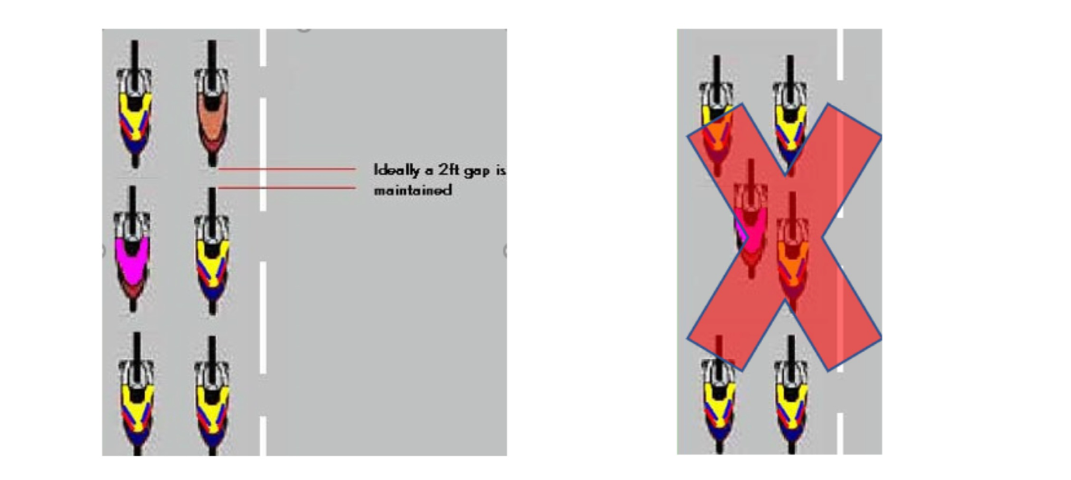
Singling out
For narrow roads or where there is heavy traffic, the group may need to ‘single out’ and it is essential that this is done smoothly whilst keeping the existing speed – an agreed system should be used each time e.g. inside rider moves ahead to allow the outside rider to slip in behind. Moving into single file will double the length of the group and may encourage drivers to overtake where it is not safe to do so. Decide what is safest for the group. To move back into pairs the leading riders reposition side by side with everyone slotting back into their position. It is vital that the lead riders proceed slowly as those at the back will have many bike lengths to make up.
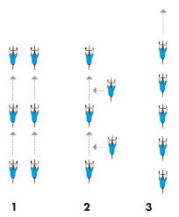

Avoid freewheeling at the front of the group
It requires more effort to cycle at the front of a group. Always keep pedalling when at the front of the group. Cyclists within a group should never tailgate or overlap wheels with other riders as this allows no reaction space if something happens unexpectedly (half wheeling).

Taking a turn at the front (“Up and over/change up/roll over”)
When a ‘change’ is called, the outside line should increase the pace very slightly, moving up without significantly increasing the speed.
The cyclist at the front of the outside line should only move inside when they are a safe distance ahead of the inside cyclist. This is to avoid touching wheels and causing an accident. Everyone then moves up on the outside. At the rear of the group the last rider in the inner line will move over and join the outer line. The outside line should ease pace back to the normal group pace. A cyclist
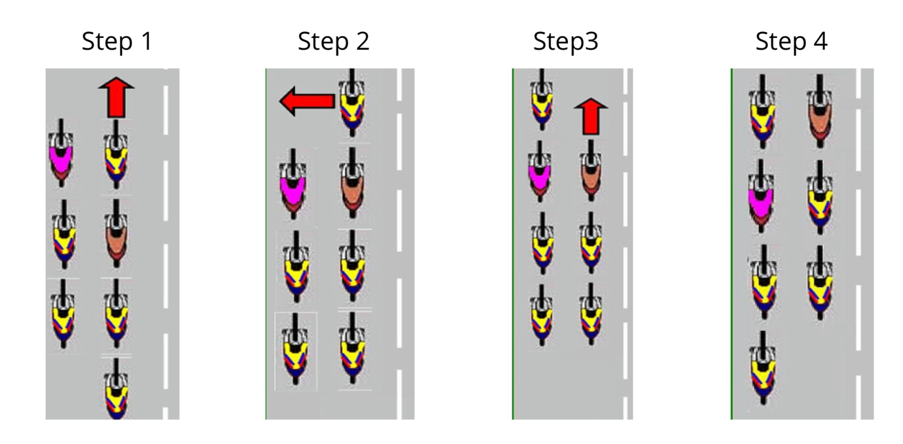
should always shoulder check before changing position.

Other useful terminology
‘Holding the line’ – cyclists in a group need to cycle in a steady, straight line, holding the wheel of the rider ahead, so that they are predictable to both the other riders and other road users.

‘Half Wheeling’- the action by an individual, when he or she rides beside another rider and is always pushing the pace so that they are just enough ahead and the other rider(s) feel like they are constantly trying to catch up. Half wheeling by pulling ahead can cause the groups pace to increase because as the rider being half wheeled tries to pull level and the half wheeling rider will often increase the pace. The differences in pace will radiate through the group forcing riders in the group to work harder to keep the pace or alternatively result in the group becoming fragmented.

After the cycle

Clean Your Bike!
After a ride it is important to make sure you clean your bike. Cleaning your bike ensures you maintain the performance of your bike. If the moving parts have got muddy or picked up road salt, give the bike a quick hose down keeping the drive train, derailleur, jockey wheels and other moving parts moving freely. Check for loose parts, rough or loose bearing, tyre condition etc.
Keeping your bike well maintained will help to sustain the equipment and components longer term.

If you would like more information, please check out the following guide
https://www.communitybikerides.ie/images/uploads/resources/Guide_to_cycling_on_the_road.pdf

